ASSIGNMENT-2

NAME:M.Tarun Antony

REGISTER NUMBER:240701556
📄 Memory Recall – Instruction Page Description
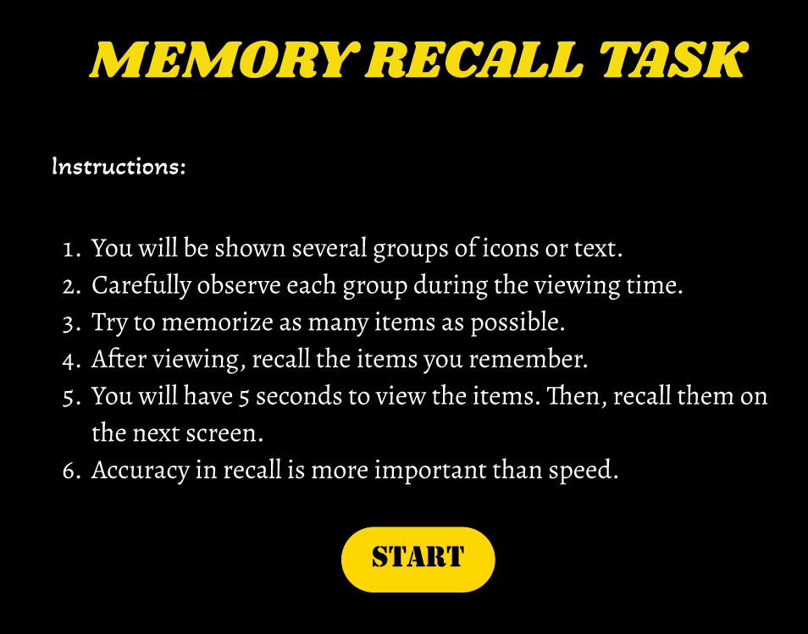

This screen serves as the introduction and guidance page for the Memory Recall task. It clearly explains the objective of the activity and prepares the user before starting the task.

The page presents a set of step-by-step instructions that inform the user about how the memory recall exercise works. Users are told that they will be shown a group of icons for a limited time and are encouraged to observe them carefully by mentally grouping similar items, a technique known as chunking. This helps improve short-term memory and recall accuracy.

The instructions also explain that after the viewing phase, users will move to a recall phase where they must remember and identify the icons they observed. Emphasis is placed on accuracy over speed, helping users stay calm and focused.

A clear “START” button is placed at the bottom of the screen, allowing users to begin the task once they have read and understood the instructions. The simple layout, soft color palette, and minimal design reduce cognitive load and ensure clarity.

This page plays a crucial role in setting user expectations and ensuring a smooth transition into the interactive memory recall activity.

🧠 Memory Recall – Chunking Phase Screen Description
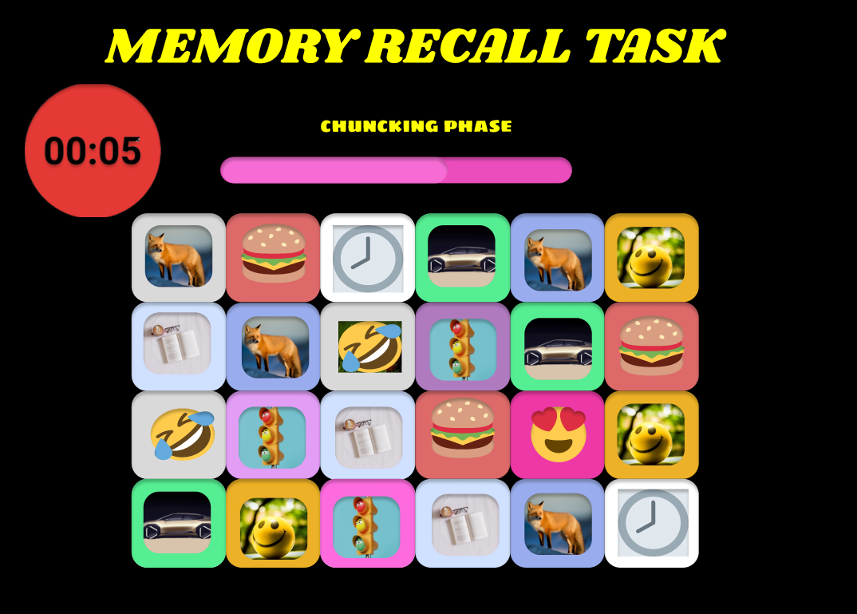

This screen represents the chunking (observation) phase of the Memory Recall task, where users are required to carefully observe and memorize a set of icons displayed on the screen within a limited time.

At the top of the screen, a countdown timer and a progress bar indicate the remaining viewing time, helping users stay aware of the time constraint. The label “chunking phase” informs users that this stage focuses on observation rather than recall.

The central area displays a grid of icon tiles, each containing emojis or symbols arranged in a structured pattern. Users are encouraged to apply the chunking technique by mentally grouping similar icons together, which supports better short-term memory retention.

The minimal layout, consistent color scheme, and evenly spaced tiles are designed to reduce distractions and keep the user focused on visual memory processing. No interaction is required during this phase, allowing users to fully concentrate on observation.

This screen plays a critical role in preparing users for the upcoming recall phase, where they will be asked
to reproduce or identify the Icons they remember.

🧠 Memory Recall – Recall Phase Screen Description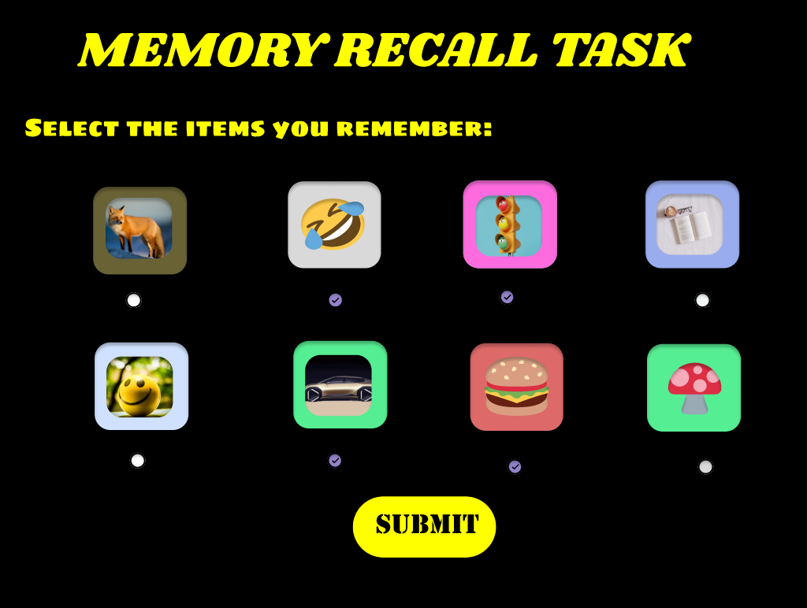
This screen represents the recall phase of the Memory Recall task, where users actively test their memory after completing the observation (chunking) phase.

Users are instructed to select the icons they remember from the previously displayed set. The screen presents a grid of selectable tiles, each containing an emoji or symbol. Some icons were shown during the chunking phase, while others act as distractors, requiring users to carefully recall and differentiate between familiar and unfamiliar items.

Small indicators below the tiles visually represent selection feedback, helping users understand which icons they have chosen. This interaction encourages focused recall rather than guessing.

The simple layout and consistent design reduce cognitive load and allow users to concentrate fully on memory retrieval. This phase evaluates the effectiveness of the user’s chunking strategy and short-term memory performance, forming the core assessment of the task.

🏁 Memory Recall – Result Screen Description

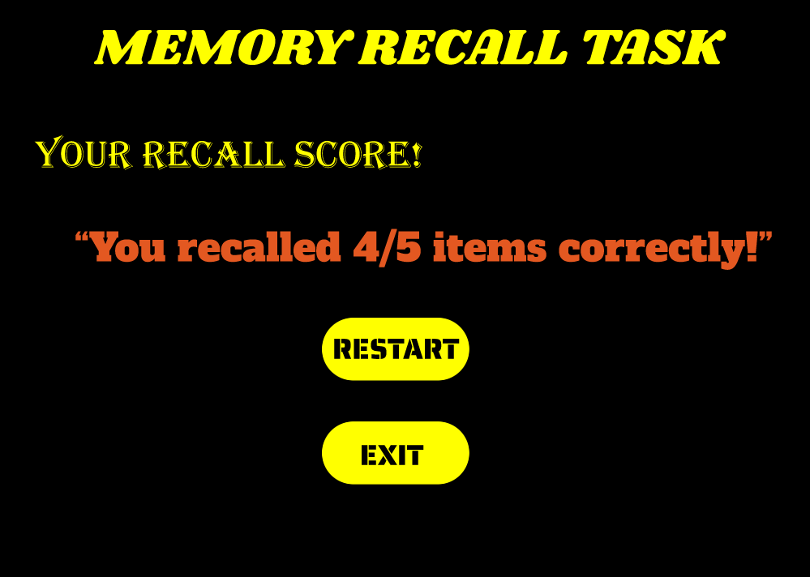
This screen displays the final result of the Memory Recall task and provides clear feedback on the user’s performance.

At the top, the screen maintains the “Memory Recall” title for consistency. The user’s performance is highlighted through a prominent score display, shown inside a circular visual element (e.g., 5/5), making the result easy to understand at a glance.

The circular design draws attention to the outcome and provides a sense of completion and achievement. This positive visual feedback helps reinforce user engagement and motivates improvement in future attempts.

The clean layout and minimal content ensure that the user’s focus remains on their performance outcome, marking a clear conclusion to the memory recall activity.

This result screen effectively summarizes the user’s recall accuracy and completes the overall user flow of the task.
https://www.figma.com/proto/MRgZkAfzMNSvfnMcg80E2H/chunking--Copy-?node-id=2-2&starting-point-node-id=2%3A2&t=n4zBkVfDsBJAacYQ-1
https://www.figma.com/proto/MRgZkAfzMNSvfnMcg80E2H/chunking--Copy-?node-id=17-348&starting-point-node-id=2%3A2&t=n4zBkVfDsBJAacYQ-1
https://www.figma.com/proto/MRgZkAfzMNSvfnMcg80E2H/chunking--Copy-?node-id=15-566&starting-point-node-id=2%3A2&t=n4zBkVfDsBJAacYQ-1

https://www.figma.com/proto/MRgZkAfzMNSvfnMcg80E2H/chunking--Copy-?node-id=20-919&starting-point-node-id=2%3A2&t=n4zBkVfDsBJAacYQ-1

